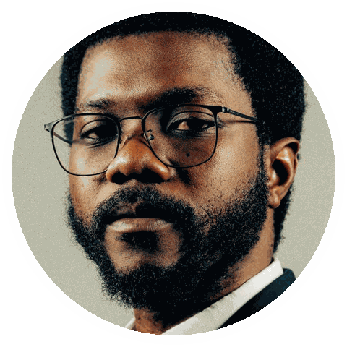  ● Details  Portfolio: yoursite.com  Available: September  Engagement: contract  Based: London / remote  ● Strengths  Research  Facilitation  Product strategy  ● Contact  City, ST  you@email.com  (555) 123-4567  linkedin.com/in/yourname |  | INDEPENDENT PRACTICE / 2026  Kwame Boateng  Independent UX Consultant  ● Independent profile  Independent UX consultant helping complex organisations find the right problem, align teams, and ship simpler customer experiences.  ● Selected engagements  - Led a cross-functional improvement programme that increased on-time delivery from 84% to 96% in two quarters.  - Redesigned the team’s operating cadence, removing 18 hours of manual reporting work each month.  - Owned a high-visibility portfolio and finished the year 14% ahead of the agreed performance target.  - Built a simple planning system that improved handoffs, accountability, and decision speed.  ● Ways of working  Research sprints · Embedded product work · Facilitation · Remote collaboration
  Principal UX Consultant  Northgate Group | City, ST | 2022 - Present
  Senior Product Designer  Brightwater Ltd | City, ST | 2019 - 2022

