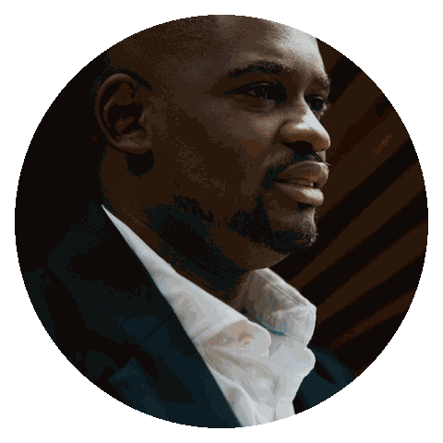  DETAILS  Core skill  Core skill  Tool / platform  Method  Certification  STRENGTHS  Leadership  Planning  Communication  CONTACT  City, ST  you@email.com  (555) 123-4567  linkedin.com/in/yourname |  | PROFESSIONAL RÉSUMÉ / 2026  Daniel Okafor  MARKETING MANAGER  PROFESSIONAL SUMMARY  Marketing manager combining audience insight, crisp positioning, and disciplined campaign operations to create durable commercial growth.  EXPERIENCE  - Led a cross-functional improvement programme that increased on-time delivery from 84% to 96% in two quarters.  - Redesigned the team’s operating cadence, removing 18 hours of manual reporting work each month.  - Partnered with commercial and technical leaders to launch a priority initiative across 12 locations.  - Coached six emerging leaders; four earned expanded roles within 18 months.  - Owned a high-visibility portfolio and finished the year 14% ahead of the agreed performance target.  - Built a simple planning system that improved handoffs, accountability, and decision speed.  - Presented monthly performance narratives to senior leadership, translating analysis into clear decisions.  - Promoted after delivering the strongest client-retention result in the team for two consecutive years.  - Created practical playbooks adopted by three adjacent teams as the new operating standard.  EDUCATION  Honours · Leadership society · Relevant professional coursework
  Marketing Manager  Northgate Group | City, ST | 2022 - Present
  Campaign Lead  Brightwater Ltd | City, ST | 2019 - 2022
  Marketing Specialist  Halden & Co | City, ST | 2017 - 2019
  B.A. Marketing  State University | City, ST | 2017

